https://спроси.дом.рф/instructions/selskaya-ipoteka-voprosy-i-otvety/
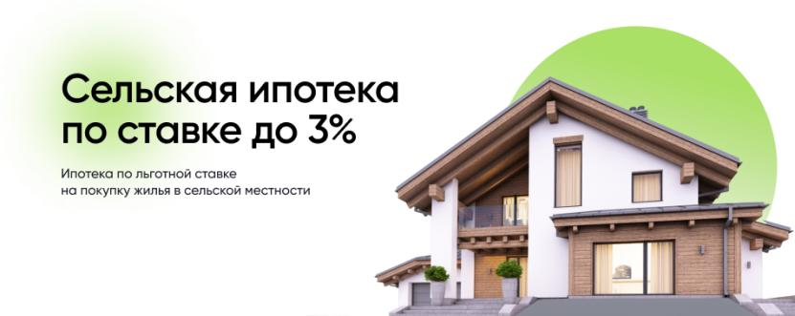

https://спроси.дом.рф/catalog/lgotnaya-ipoteka/

https://спроси.дом.рф/catalog/semeinaya-ipoteka/
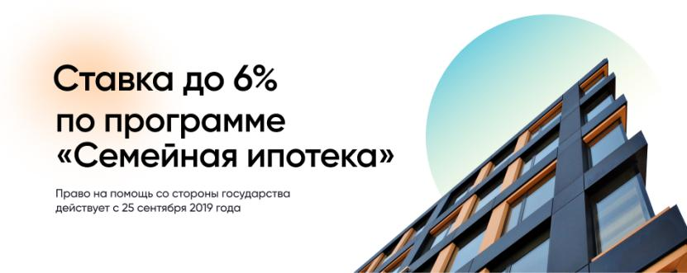

https://спроси.дом.рф//catalog/lgotnaya-ipoteka-dlya- it-spetsialistov/

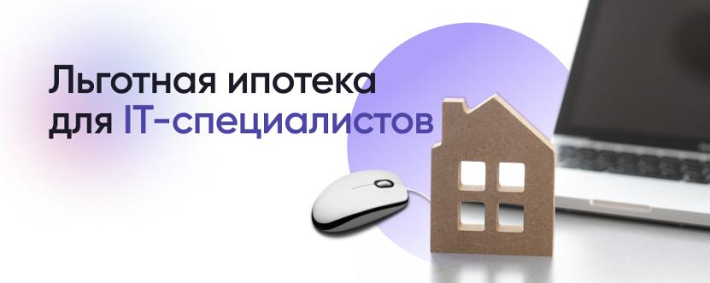
https://спроси.дом.рф/catalog/pomoshh-mnogodetnym-semyam-v-pogashenii-ipoteki/
